Bùi Hải Đường - 1150080012 - Cnpm1
+ Lab7
-Thực hành 1:
1.1:Chuẩn bị data sql:
CREATE TABLE NhaXuatBan (
MaXB NVARCHAR(10) PRIMARY KEY,
TenXB NVARCHAR(50),
DiaChi NVARCHAR(100)
);
1.2: Form1.cs
using System;
using System.Data;
using System.Data.SqlClient;
using System.Windows.Forms;

namespace BuiHaiDuong_1150080012_Lab7
{
public partial class Form1 : Form
{
// 🔹 Chuỗi kết nối tới SQL Server của bạn
string strCon = @"Data Source=LAPTOP-1OLPGQ5K\SUGAR;
Initial Catalog=QuanLyBanSach;
Integrated Security=True;
TrustServerCertificate=True";

// 🔹 Đối tượng kết nối
SqlConnection sqlCon = null;

public Form1()
{
InitializeComponent();
}

// 🟢 Hàm mở kết nối
private void MoKetNoi()
{
if (sqlCon == null)
sqlCon = new SqlConnection(strCon);
if (sqlCon.State == ConnectionState.Closed)
sqlCon.Open();
}

// 🔴 Hàm đóng kết nối
private void DongKetNoi()
{
if (sqlCon != null && sqlCon.State == ConnectionState.Open)
sqlCon.Close();
}

// 🖱️ Xử lý sự kiện khi bấm nút Hiển thị danh sách
private void btnHienThi_Click(object sender, EventArgs e)
{
try
{
MoKetNoi();

// Câu lệnh SQL hiển thị dữ liệu
string sql = "SELECT * FROM NhaXuatBan";

// SqlDataAdapter để lấy dữ liệu
SqlDataAdapter adapter = new SqlDataAdapter(sql, sqlCon);

// Đổ dữ liệu vào DataSet
DataSet ds = new DataSet();
adapter.Fill(ds, "tblNhaXuatBan");

// Gán nguồn dữ liệu cho DataGridView
dgvDanhSach.DataSource = ds.Tables["tblNhaXuatBan"];
}
catch (Exception ex)
{
MessageBox.Show("Lỗi: " + ex.Message);
}
finally
{
DongKetNoi();
}
}
}
}
1.3: Form3.design.cs
namespace BuiHaiDuong_1150080012_Lab7
{
partial class Form1
{
private System.ComponentModel.IContainer components = null;

/// <summary>
/// Dọn tài nguyên khi đóng form
/// </summary>
/// <param name="disposing"></param>
protected override void Dispose(bool disposing)
{
if (disposing && (components != null))
{
components.Dispose();
}
base.Dispose(disposing);
}

#region Windows Form Designer generated code

private System.Windows.Forms.Button btnHienThi;
private System.Windows.Forms.DataGridView dgvDanhSach;

/// <summary>
/// Hàm khởi tạo giao diện
/// </summary>
private void InitializeComponent()
{
this.btnHienThi = new System.Windows.Forms.Button();
this.dgvDanhSach = new System.Windows.Forms.DataGridView();
((System.ComponentModel.ISupportInitialize)(this.dgvDanhSach)).BeginInit();
this.SuspendLayout();
//
// btnHienThi
//
this.btnHienThi.Font = new System.Drawing.Font("Segoe UI", 10F, System.Drawing.FontStyle.Bold);
this.btnHienThi.Location = new System.Drawing.Point(25, 20);
this.btnHienThi.Name = "btnHienThi";
this.btnHienThi.Size = new System.Drawing.Size(180, 40);
this.btnHienThi.TabIndex = 0;
this.btnHienThi.Text = "Hiển thị danh sách";
this.btnHienThi.UseVisualStyleBackColor = true;
this.btnHienThi.Click += new System.EventHandler(this.btnHienThi_Click);
//
// dgvDanhSach
//
this.dgvDanhSach.AllowUserToAddRows = false;
this.dgvDanhSach.AllowUserToDeleteRows = false;
this.dgvDanhSach.Anchor = ((System.Windows.Forms.AnchorStyles)((((System.Windows.Forms.AnchorStyles.Top | System.Windows.Forms.AnchorStyles.Bottom)
| System.Windows.Forms.AnchorStyles.Left)
| System.Windows.Forms.AnchorStyles.Right)));
this.dgvDanhSach.AutoSizeColumnsMode = System.Windows.Forms.DataGridViewAutoSizeColumnsMode.Fill;
this.dgvDanhSach.ColumnHeadersHeightSizeMode = System.Windows.Forms.DataGridViewColumnHeadersHeightSizeMode.AutoSize;
this.dgvDanhSach.Location = new System.Drawing.Point(25, 80);
this.dgvDanhSach.Name = "dgvDanhSach";
this.dgvDanhSach.ReadOnly = true;
this.dgvDanhSach.RowHeadersWidth = 51;
this.dgvDanhSach.RowTemplate.Height = 29;
this.dgvDanhSach.Size = new System.Drawing.Size(740, 330);
this.dgvDanhSach.TabIndex = 1;
//
// Form1
//
this.AutoScaleDimensions = new System.Drawing.SizeF(8F, 20F);
this.AutoScaleMode = System.Windows.Forms.AutoScaleMode.Font;
this.ClientSize = new System.Drawing.Size(800, 450);
this.Controls.Add(this.dgvDanhSach);
this.Controls.Add(this.btnHienThi);
this.Name = "Form1";
this.StartPosition = System.Windows.Forms.FormStartPosition.CenterScreen;
this.Text = "Hiển thị dữ liệu - Lab 7 (Bùi Hải Dương)";
((System.ComponentModel.ISupportInitialize)(this.dgvDanhSach)).EndInit();
this.ResumeLayout(false);
}

#endregion
}
}
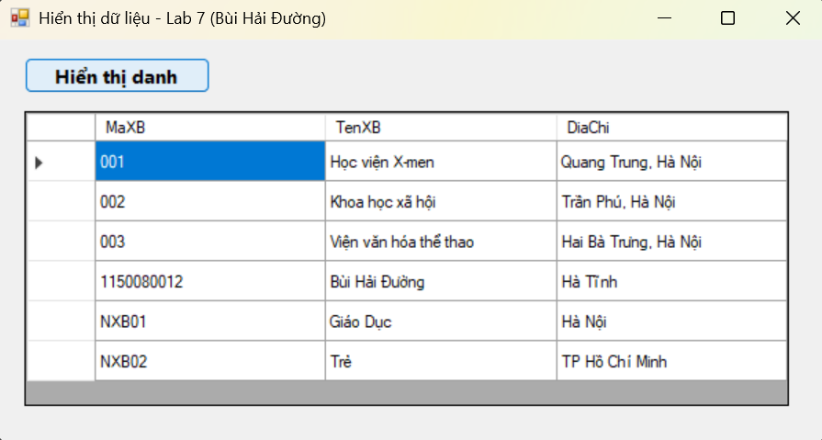

-Thực hành 2:

2.1: Form2.cs
using System;
using System.Data;
using System.Data.SqlClient;
using System.Windows.Forms;

namespace BuiHaiDuong_1150080012_Lab7
{
public partial class Form2 : Form
{
string strCon = @"Data Source=LAPTOP-1OLPGQ5K\SUGAR;
Initial Catalog=QuanLyBanSach;
Integrated Security=True;
TrustServerCertificate=True";

SqlConnection sqlCon = null;
SqlDataAdapter adapter = null;
DataSet ds = null;
int vt = -1; // vị trí hàng được chọn trong DataGridView

public Form2()
{
InitializeComponent();
}

private void MoKetNoi()
{
if (sqlCon == null)
sqlCon = new SqlConnection(strCon);
if (sqlCon.State == ConnectionState.Closed)
sqlCon.Open();
}

private void DongKetNoi()
{
if (sqlCon != null && sqlCon.State == ConnectionState.Open)
sqlCon.Close();
}

private void HienThiDuLieu()
{
MoKetNoi();
string query = "SELECT * FROM NhaXuatBan";
adapter = new SqlDataAdapter(query, sqlCon);
SqlCommandBuilder builder = new SqlCommandBuilder(adapter);
ds = new DataSet();
adapter.Fill(ds, "tblNhaXuatBan");
dgvDanhSach.DataSource = ds.Tables["tblNhaXuatBan"];
DongKetNoi();
}

private void XoaForm()
{
txtMaXB.Text = txtTenXB.Text = txtDiaChi.Text = "";
}

private void Form2_Load(object sender, EventArgs e)
{
HienThiDuLieu();
XoaForm();
}

private void dgvDanhSach_CellClick(object sender, DataGridViewCellEventArgs e)
{
vt = e.RowIndex;
if (vt == -1) return;

DataRow row = ds.Tables["tblNhaXuatBan"].Rows[vt];
txtMaXB.Text = row["MaXB"].ToString().Trim();
txtTenXB.Text = row["TenXB"].ToString().Trim();
txtDiaChi.Text = row["DiaChi"].ToString().Trim();
}

private void btnCapNhat_Click(object sender, EventArgs e)
{
if (vt == -1)
{
MessageBox.Show("Vui lòng chọn dữ liệu cần chỉnh sửa!");
return;
}

try
{
DataRow row = ds.Tables["tblNhaXuatBan"].Rows[vt];
row.BeginEdit();
row["MaXB"] = txtMaXB.Text.Trim();
row["TenXB"] = txtTenXB.Text.Trim();
row["DiaChi"] = txtDiaChi.Text.Trim();
row.EndEdit();

int kq = adapter.Update(ds.Tables["tblNhaXuatBan"]);
if (kq > 0)
{
MessageBox.Show("Cập nhật dữ liệu thành công!");
HienThiDuLieu();
XoaForm();
}
else
MessageBox.Show("Không thể cập nhật dữ liệu!");
}
catch (Exception ex)
{
MessageBox.Show("Lỗi: " + ex.Message);
}
}
}
}

2.2: Form2.Design.cs
namespace BuiHaiDuong_1150080012_Lab7
{
partial class Form2
{
private System.ComponentModel.IContainer components = null;

protected override void Dispose(bool disposing)
{
if (disposing && (components != null))
{
components.Dispose();
}
base.Dispose(disposing);
}

#region Windows Form Designer generated code

private System.Windows.Forms.DataGridView dgvDanhSach;
private System.Windows.Forms.TextBox txtMaXB;
private System.Windows.Forms.TextBox txtTenXB;
private System.Windows.Forms.TextBox txtDiaChi;
private System.Windows.Forms.Button btnCapNhat;
private System.Windows.Forms.Label lblMaXB;
private System.Windows.Forms.Label lblTenXB;
private System.Windows.Forms.Label lblDiaChi;
private System.Windows.Forms.Label lblDanhSach;
private System.Windows.Forms.Label lblNhapThongTin;
private System.Windows.Forms.Label lblTieuDe;

private void InitializeComponent()
{
this.dgvDanhSach = new System.Windows.Forms.DataGridView();
this.txtMaXB = new System.Windows.Forms.TextBox();
this.txtTenXB = new System.Windows.Forms.TextBox();
this.txtDiaChi = new System.Windows.Forms.TextBox();
this.btnCapNhat = new System.Windows.Forms.Button();
this.lblMaXB = new System.Windows.Forms.Label();
this.lblTenXB = new System.Windows.Forms.Label();
this.lblDiaChi = new System.Windows.Forms.Label();
this.lblDanhSach = new System.Windows.Forms.Label();
this.lblNhapThongTin = new System.Windows.Forms.Label();
this.lblTieuDe = new System.Windows.Forms.Label();
((System.ComponentModel.ISupportInitialize)(this.dgvDanhSach)).BeginInit();
this.SuspendLayout();
//
// lblTieuDe
//
this.lblTieuDe.AutoSize = true;
this.lblTieuDe.Font = new System.Drawing.Font("Segoe UI", 12F, System.Drawing.FontStyle.Bold);
this.lblTieuDe.Location = new System.Drawing.Point(250, 10);
this.lblTieuDe.Text = "Cập nhật dữ liệu Nhà xuất bản";
//
// lblDanhSach
//
this.lblDanhSach.AutoSize = true;
this.lblDanhSach.Location = new System.Drawing.Point(20, 50);
this.lblDanhSach.Text = "Danh sách nhà xuất bản:";
//
// dgvDanhSach
//
this.dgvDanhSach.Location = new System.Drawing.Point(20, 70);
this.dgvDanhSach.Size = new System.Drawing.Size(400, 300);
this.dgvDanhSach.AutoSizeColumnsMode = System.Windows.Forms.DataGridViewAutoSizeColumnsMode.Fill;
this.dgvDanhSach.CellClick += new System.Windows.Forms.DataGridViewCellEventHandler(this.dgvDanhSach_CellClick);
//
// lblNhapThongTin
//
this.lblNhapThongTin.AutoSize = true;
this.lblNhapThongTin.Location = new System.Drawing.Point(450, 50);
this.lblNhapThongTin.Text = "Nhập thông tin:";
//
// lblMaXB
//
this.lblMaXB.AutoSize = true;
this.lblMaXB.Location = new System.Drawing.Point(450, 90);
this.lblMaXB.Text = "Mã NXB:";
//
// txtMaXB
//
this.txtMaXB.Location = new System.Drawing.Point(520, 85);
this.txtMaXB.Width = 200;
//
// lblTenXB
//
this.lblTenXB.AutoSize = true;
this.lblTenXB.Location = new System.Drawing.Point(450, 130);
this.lblTenXB.Text = "Tên NXB:";
//
// txtTenXB
//
this.txtTenXB.Location = new System.Drawing.Point(520, 125);
this.txtTenXB.Width = 200;
//
// lblDiaChi
//
this.lblDiaChi.AutoSize = true;
this.lblDiaChi.Location = new System.Drawing.Point(450, 170);
this.lblDiaChi.Text = "Địa chỉ:";
//
// txtDiaChi
//
this.txtDiaChi.Location = new System.Drawing.Point(520, 165);
this.txtDiaChi.Width = 200;
//
// btnCapNhat
//
this.btnCapNhat.Font = new System.Drawing.Font("Segoe UI", 10F);
this.btnCapNhat.Location = new System.Drawing.Point(520, 210);
this.btnCapNhat.Size = new System.Drawing.Size(120, 40);
this.btnCapNhat.Text = "Cập nhật";
this.btnCapNhat.Click += new System.EventHandler(this.btnCapNhat_Click);
//
// Form2
//
this.ClientSize = new System.Drawing.Size(760, 400);
this.Controls.Add(this.lblTieuDe);
this.Controls.Add(this.lblDanhSach);
this.Controls.Add(this.dgvDanhSach);
this.Controls.Add(this.lblNhapThongTin);
this.Controls.Add(this.lblMaXB);
this.Controls.Add(this.txtMaXB);
this.Controls.Add(this.lblTenXB);
this.Controls.Add(this.txtTenXB);
this.Controls.Add(this.lblDiaChi);
this.Controls.Add(this.txtDiaChi);
this.Controls.Add(this.btnCapNhat);
this.StartPosition = System.Windows.Forms.FormStartPosition.CenterScreen;
this.Text = "Cập nhật dữ liệu - Lab 7 (Form2)";
this.Load += new System.EventHandler(this.Form2_Load);
((System.ComponentModel.ISupportInitialize)(this.dgvDanhSach)).EndInit();
this.ResumeLayout(false);
this.PerformLayout();
}

#endregion
}
}
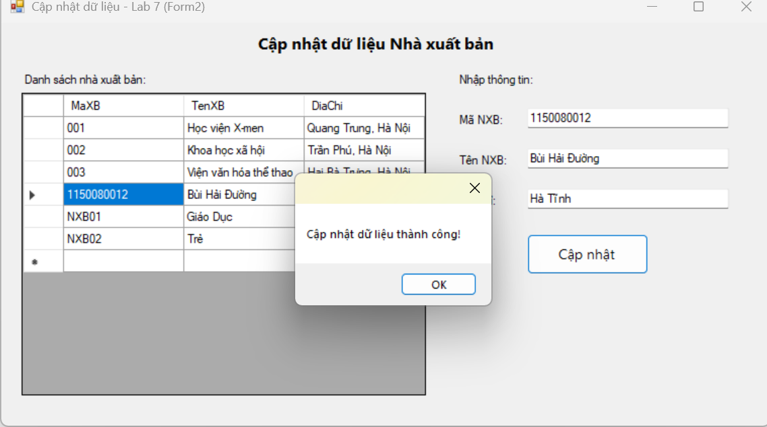

-Thực hành 3:

3.1: Form3.cs
using System;
using System.Data;
using System.Data.SqlClient;
using System.Windows.Forms;

namespace BuiHaiDuong_1150080012_Lab7
{
public partial class Form3 : Form
{
string strCon = @"Data Source=LAPTOP-1OLPGQ5K\SUGAR;
Initial Catalog=QuanLyBanSach;
Integrated Security=True;
TrustServerCertificate=True";

SqlConnection sqlCon = null;
SqlDataAdapter adapter = null;
DataSet ds = null;
int vt = -1;

public Form3()
{
InitializeComponent();
}

private void MoKetNoi()
{
if (sqlCon == null)
sqlCon = new SqlConnection(strCon);
if (sqlCon.State == ConnectionState.Closed)
sqlCon.Open();
}

private void DongKetNoi()
{
if (sqlCon != null && sqlCon.State == ConnectionState.Open)
sqlCon.Close();
}

private void HienThiDuLieu()
{
MoKetNoi();
string query = "SELECT * FROM NhaXuatBan";
adapter = new SqlDataAdapter(query, sqlCon);
SqlCommandBuilder builder = new SqlCommandBuilder(adapter);
ds = new DataSet();
adapter.Fill(ds, "tblNhaXuatBan");
dgvDanhSach.DataSource = ds.Tables["tblNhaXuatBan"];
DongKetNoi();
}

private void Form3_Load(object sender, EventArgs e)
{
HienThiDuLieu();
}

private void dgvDanhSach_CellClick(object sender, DataGridViewCellEventArgs e)
{
vt = e.RowIndex;
if (vt == -1) return;

DataRow row = ds.Tables["tblNhaXuatBan"].Rows[vt];
txtMaXB.Text = row["MaXB"].ToString().Trim();
txtTenXB.Text = row["TenXB"].ToString().Trim();
txtDiaChi.Text = row["DiaChi"].ToString().Trim();
}

private void btnXoa_Click(object sender, EventArgs e)
{
if (vt == -1)
{
MessageBox.Show("Vui lòng chọn dữ liệu cần xóa!");
return;
}

DialogResult confirm = MessageBox.Show(
"Bạn có chắc chắn muốn xóa bản ghi này?",
"Xác nhận xóa",
MessageBoxButtons.YesNo,
MessageBoxIcon.Warning
);

if (confirm == DialogResult.Yes)
{
try
{
DataRow row = ds.Tables["tblNhaXuatBan"].Rows[vt];
row.Delete();

int kq = adapter.Update(ds.Tables["tblNhaXuatBan"]);
if (kq > 0)
{
MessageBox.Show("Xóa dữ liệu thành công!");
HienThiDuLieu();
txtMaXB.Text = txtTenXB.Text = txtDiaChi.Text = "";
}
else
MessageBox.Show("Không thể xóa dữ liệu!");
}
catch (Exception ex)
{
MessageBox.Show("Lỗi: " + ex.Message);
}
}
}
}
}
3.2: Form3.Design.cs
using System;
using System.Data;
using System.Data.SqlClient;
using System.Windows.Forms;

namespace BuiHaiDuong_1150080012_Lab7
{
public partial class Form3 : Form
{
string strCon = @"Data Source=LAPTOP-1OLPGQ5K\SUGAR;
Initial Catalog=QuanLyBanSach;
Integrated Security=True;
TrustServerCertificate=True";

SqlConnection sqlCon = null;
SqlDataAdapter adapter = null;
DataSet ds = null;
int vt = -1;

public Form3()
{
InitializeComponent();
}

private void MoKetNoi()
{
if (sqlCon == null)
sqlCon = new SqlConnection(strCon);
if (sqlCon.State == ConnectionState.Closed)
sqlCon.Open();
}

private void DongKetNoi()
{
if (sqlCon != null && sqlCon.State == ConnectionState.Open)
sqlCon.Close();
}

private void HienThiDuLieu()
{
MoKetNoi();
string query = "SELECT * FROM NhaXuatBan";
adapter = new SqlDataAdapter(query, sqlCon);
SqlCommandBuilder builder = new SqlCommandBuilder(adapter);
ds = new DataSet();
adapter.Fill(ds, "tblNhaXuatBan");
dgvDanhSach.DataSource = ds.Tables["tblNhaXuatBan"];
DongKetNoi();
}

private void Form3_Load(object sender, EventArgs e)
{
HienThiDuLieu();
}

private void dgvDanhSach_CellClick(object sender, DataGridViewCellEventArgs e)
{
vt = e.RowIndex;
if (vt == -1) return;

DataRow row = ds.Tables["tblNhaXuatBan"].Rows[vt];
txtMaXB.Text = row["MaXB"].ToString().Trim();
txtTenXB.Text = row["TenXB"].ToString().Trim();
txtDiaChi.Text = row["DiaChi"].ToString().Trim();
}

private void btnXoa_Click(object sender, EventArgs e)
{
if (vt == -1)
{
MessageBox.Show("Vui lòng chọn dữ liệu cần xóa!");
return;
}

DialogResult confirm = MessageBox.Show(
"Bạn có chắc chắn muốn xóa bản ghi này?",
"Xác nhận xóa",
MessageBoxButtons.YesNo,
MessageBoxIcon.Warning
);

if (confirm == DialogResult.Yes)
{
try
{
DataRow row = ds.Tables["tblNhaXuatBan"].Rows[vt];
row.Delete();

int kq = adapter.Update(ds.Tables["tblNhaXuatBan"]);
if (kq > 0)
{
MessageBox.Show("Xóa dữ liệu thành công!");
HienThiDuLieu();
txtMaXB.Text = txtTenXB.Text = txtDiaChi.Text = "";
}
else
MessageBox.Show("Không thể xóa dữ liệu!");
}
catch (Exception ex)
{
MessageBox.Show("Lỗi: " + ex.Message);
}
}
}
}
}
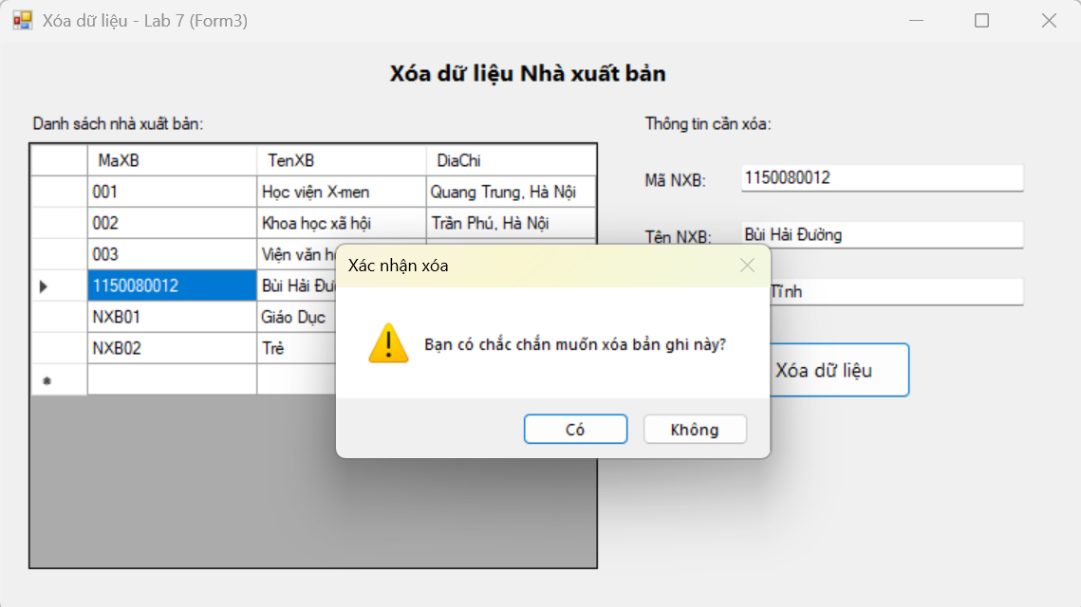
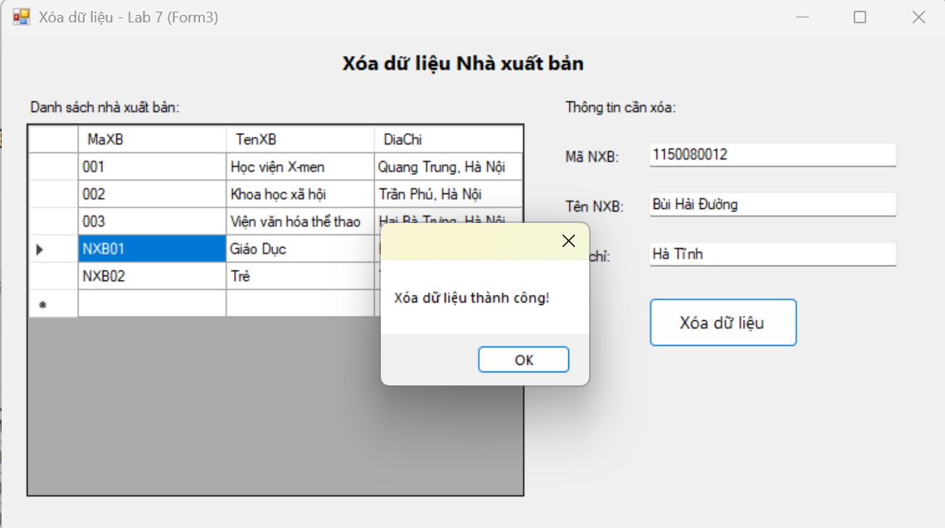

Phần 4: Lập trình Cơ sở dữ liệu với C#
+ Chuẩn bị csdl:
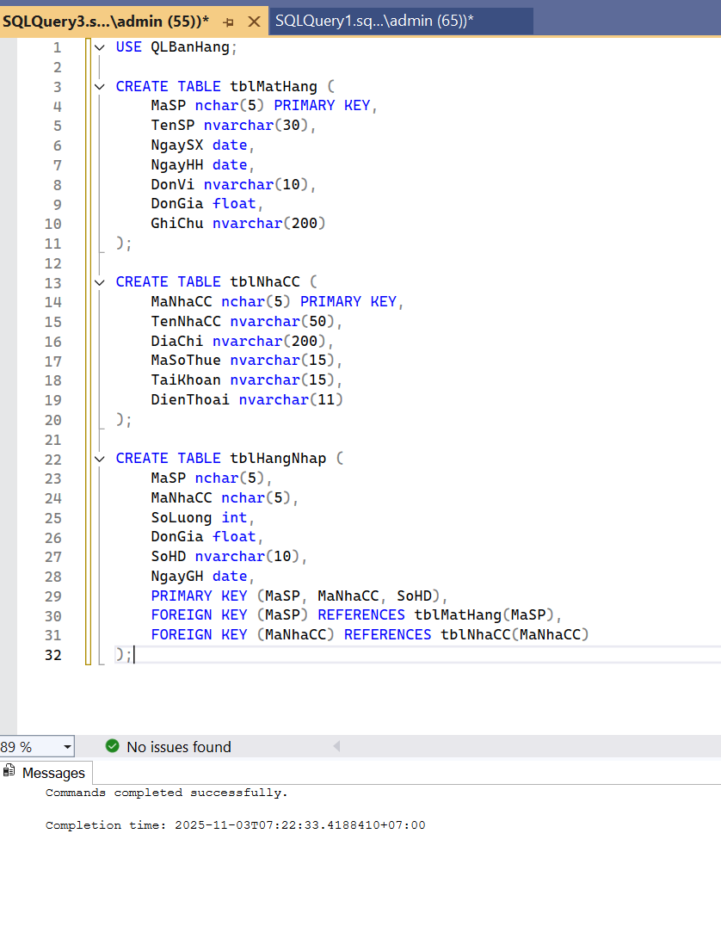

Lập trình cơ sở dữ liệu với C#” (hiển thị, thêm, sửa, xóa dữ liệu SQL bằng ADO.NET và DataGridView).

Form4.cs
using System;
using System.Data;
using System.Data.SqlClient;
using System.Windows.Forms;

namespace BuiHaiDuong_1150080012_Lab7
{
public partial class Form4 : Form
{
SqlConnection conn;
SqlDataAdapter da;
DataTable dt;
SqlCommand cmd;

string strCon = @"Data Source=LAPTOP-1OLPGQ5K\SUGAR;
Initial Catalog=QLBanHang;
Integrated Security=True;
TrustServerCertificate=True";

public Form4()
{
InitializeComponent();
}

private void Form4_Load(object sender, EventArgs e)
{
conn = new SqlConnection(strCon);
LoadData();
}

// Hàm nạp dữ liệu lên DataGridView
private void LoadData()
{
try
{
conn.Open();
string sql = "SELECT * FROM tblMatHang";
da = new SqlDataAdapter(sql, conn);
dt = new DataTable();
da.Fill(dt);
dgvDanhSach.DataSource = dt;
}
catch (Exception ex)
{
MessageBox.Show("Lỗi tải dữ liệu: " + ex.Message);
}
finally
{
conn.Close();
}
}

// Nút thêm dữ liệu
private void btnThem_Click(object sender, EventArgs e)
{
try
{
conn.Open();
string sql = "INSERT INTO tblMatHang(MaSP, TenSP, NgaySX, NgayHH, DonVi, DonGia, GhiChu) " +
"VALUES('SP01', N'Sản phẩm A', GETDATE(), DATEADD(DAY, 30, GETDATE()), N'Cái', 10000, N'Hàng mới')";
cmd = new SqlCommand(sql, conn);
cmd.ExecuteNonQuery();
MessageBox.Show("Đã thêm dữ liệu thành công!");
LoadData();
}
catch (Exception ex)
{
MessageBox.Show("Lỗi thêm: " + ex.Message);
}
finally
{
conn.Close();
}
}

// Nút sửa dữ liệu
private void btnSua_Click(object sender, EventArgs e)
{
if (dgvDanhSach.CurrentRow == null)
{
MessageBox.Show("Vui lòng chọn một dòng để sửa!");
return;
}

string ma = dgvDanhSach.CurrentRow.Cells["MaSP"].Value.ToString();

try
{
conn.Open();
string sql = $"UPDATE tblMatHang SET TenSP = N'Sản phẩm cập nhật', DonGia = DonGia + 5000 WHERE MaSP = '{ma}'";
cmd = new SqlCommand(sql, conn);
cmd.ExecuteNonQuery();
MessageBox.Show("Đã cập nhật thành công!");
LoadData();
}
catch (Exception ex)
{
MessageBox.Show("Lỗi sửa: " + ex.Message);
}
finally
{
conn.Close();
}
}

// Nút xóa dữ liệu
private void btnXoa_Click(object sender, EventArgs e)
{
if (dgvDanhSach.CurrentRow == null)
{
MessageBox.Show("Vui lòng chọn một dòng để xóa!");
return;
}

string ma = dgvDanhSach.CurrentRow.Cells["MaSP"].Value.ToString();

DialogResult result = MessageBox.Show($"Bạn có chắc muốn xóa sản phẩm {ma} không?",
"Xác nhận xóa",
MessageBoxButtons.YesNo,
MessageBoxIcon.Question);

if (result == DialogResult.Yes)
{
try
{
conn.Open();
string sql = $"DELETE FROM tblMatHang WHERE MaSP = '{ma}'";
cmd = new SqlCommand(sql, conn);
cmd.ExecuteNonQuery();
MessageBox.Show("Đã xóa dữ liệu thành công!");
LoadData();
}
catch (Exception ex)
{
MessageBox.Show("Lỗi xóa: " + ex.Message);
}
finally
{
conn.Close();
}
}
}
}
}
Form4.Design.cs
namespace BuiHaiDuong_1150080012_Lab7
{
partial class Form4
{
private System.ComponentModel.IContainer components = null;

protected override void Dispose(bool disposing)
{
if (disposing && (components != null))
{
components.Dispose();
}
base.Dispose(disposing);
}

#region Windows Form Designer generated code

private System.Windows.Forms.DataGridView dgvDanhSach;
private System.Windows.Forms.Button btnThem;
private System.Windows.Forms.Button btnSua;
private System.Windows.Forms.Button btnXoa;
private System.Windows.Forms.Label lblTieuDe;

private void InitializeComponent()
{
this.dgvDanhSach = new System.Windows.Forms.DataGridView();
this.btnThem = new System.Windows.Forms.Button();
this.btnSua = new System.Windows.Forms.Button();
this.btnXoa = new System.Windows.Forms.Button();
this.lblTieuDe = new System.Windows.Forms.Label();
((System.ComponentModel.ISupportInitialize)(this.dgvDanhSach)).BeginInit();
this.SuspendLayout();

// lblTieuDe
this.lblTieuDe.AutoSize = true;
this.lblTieuDe.Font = new System.Drawing.Font("Segoe UI", 14F, System.Drawing.FontStyle.Bold);
this.lblTieuDe.Location = new System.Drawing.Point(220, 9);
this.lblTieuDe.Name = "lblTieuDe";
this.lblTieuDe.Size = new System.Drawing.Size(370, 32);
this.lblTieuDe.Text = "LẬP TRÌNH CƠ SỞ DỮ LIỆU - C#";

// dgvDanhSach
this.dgvDanhSach.AllowUserToAddRows = false;
this.dgvDanhSach.AllowUserToDeleteRows = false;
this.dgvDanhSach.Anchor = ((System.Windows.Forms.AnchorStyles)((((System.Windows.Forms.AnchorStyles.Top | System.Windows.Forms.AnchorStyles.Bottom)
| System.Windows.Forms.AnchorStyles.Left)
| System.Windows.Forms.AnchorStyles.Right)));
this.dgvDanhSach.AutoSizeColumnsMode = System.Windows.Forms.DataGridViewAutoSizeColumnsMode.Fill;
this.dgvDanhSach.ColumnHeadersHeightSizeMode = System.Windows.Forms.DataGridViewColumnHeadersHeightSizeMode.AutoSize;
this.dgvDanhSach.Location = new System.Drawing.Point(25, 100);
this.dgvDanhSach.Name = "dgvDanhSach";
this.dgvDanhSach.ReadOnly = true;
this.dgvDanhSach.RowHeadersWidth = 51;
this.dgvDanhSach.RowTemplate.Height = 29;
this.dgvDanhSach.Size = new System.Drawing.Size(750, 320);
this.dgvDanhSach.TabIndex = 0;

// btnThem
this.btnThem.Font = new System.Drawing.Font("Segoe UI", 10F);
this.btnThem.Location = new System.Drawing.Point(25, 55);
this.btnThem.Name = "btnThem";
this.btnThem.Size = new System.Drawing.Size(120, 35);
this.btnThem.TabIndex = 1;
this.btnThem.Text = "Thêm";
this.btnThem.UseVisualStyleBackColor = true;
this.btnThem.Click += new System.EventHandler(this.btnThem_Click);

// btnSua
this.btnSua.Font = new System.Drawing.Font("Segoe UI", 10F);
this.btnSua.Location = new System.Drawing.Point(160, 55);
this.btnSua.Name = "btnSua";
this.btnSua.Size = new System.Drawing.Size(120, 35);
this.btnSua.TabIndex = 2;
this.btnSua.Text = "Sửa";
this.btnSua.UseVisualStyleBackColor = true;
this.btnSua.Click += new System.EventHandler(this.btnSua_Click);

// btnXoa
this.btnXoa.Font = new System.Drawing.Font("Segoe UI", 10F);
this.btnXoa.Location = new System.Drawing.Point(295, 55);
this.btnXoa.Name = "btnXoa";
this.btnXoa.Size = new System.Drawing.Size(120, 35);
this.btnXoa.TabIndex = 3;
this.btnXoa.Text = "Xóa";
this.btnXoa.UseVisualStyleBackColor = true;
this.btnXoa.Click += new System.EventHandler(this.btnXoa_Click);

// Form4
this.AutoScaleDimensions = new System.Drawing.SizeF(8F, 20F);
this.AutoScaleMode = System.Windows.Forms.AutoScaleMode.Font;
this.ClientSize = new System.Drawing.Size(800, 450);
this.Controls.Add(this.lblTieuDe);
this.Controls.Add(this.btnXoa);
this.Controls.Add(this.btnSua);
this.Controls.Add(this.btnThem);
this.Controls.Add(this.dgvDanhSach);
this.Name = "Form4";
this.StartPosition = System.Windows.Forms.FormStartPosition.CenterScreen;
this.Text = "Quản lý CSDL - QLBanHang";
this.Load += new System.EventHandler(this.Form4_Load);
((System.ComponentModel.ISupportInitialize)(this.dgvDanhSach)).EndInit();
this.ResumeLayout(false);
this.PerformLayout();
}

#endregion
}
}

